* 1. Using R, preprocess your dataset to run with Apriori and use Weka for FP Growth.  Then run both algorithms and compare the output.  Answer the following questions on one single-spaced page:  
       
       
     Re-Submit:  
       
     1. How was Apriori tuned?

Apriori Algorithm is a very well astonished used association learning which is highly considered on a dataset with its data values and association with its each eqvivalance provided to each value associated. It would have a greater support and confidence between each value of heavier dataset internally dependent of each attributes and for that we used Apriori for it’s effective utilization and for that we would reach for effective results and also effective output analysis based on the results.

So, for our dataset, Student alcohol Consumption and then we had used Dalc and walc as a effective attribute and which help in identifying with how it would impact a student with regards of student grade, and where what other more factors relates with the best analysis in correlation with the attributes. In order to identify it varies with how best the we vary the confidence and support such best we can identify the best related analysis regarding dataset with each attribute.

R Code:   
  
  
library(arules)

library(readr)

student_por <- read_csv("~/student-por.csv")

View(student_por)

dim(student_por)

student_por[1:3,]

summary(student_por)

student=student_por

col_names <- names(student)

student[,col_names] <- lapply(student[,col_names] , factor)

student <- as(student, "transactions")

student

summary(student)

#graph

itemFrequencyPlot(student[, itemFrequency(student) > 0.8], cex.names = 1)

#overallrules

rules <- apriori(student, parameter = list(support = .1, confidence = 0.8))

rules

inspect(sort(rules,by="lift")[1:10,])

summary(rules)

#health

ruleshealth <- apriori(student, parameter = list(support = .01, confidence = 0.8),appearance = list(rhs=c("health=1","health=2","health=3","health=4","health=5"),

default="lhs"))

ruleshealth

inspect(sort(ruleshealth,by="support")[1:10,])

summary(ruleshealth)

#Walc

ruleswalc <- apriori(student, parameter = list(support = .01, confidence = 0.8),appearance = list(rhs=c("Walc=1","Walc=2","Walc=3","Walc=4","Walc=5"),

default="lhs"))

ruleswalc

inspect(sort(ruleswalc,by="support")[1:10,])

summary(ruleswalc)

#Dalc

rulesdalc <- apriori(student, parameter = list(support = .01, confidence = 0.8),appearance = list(rhs=c("Dalc=1","Dalc=2","Dalc=3","Dalc=4","Dalc=5"),

default="lhs"))

rulesdalc

inspect(sort(rulesdalc,by="support")[1:10,])

summary(rulesdalc)

#famrel

rulesfamrel <- apriori(student, parameter = list(support = .01, confidence = 0.8),appearance = list(rhs=c("famrel=1","famrel=2","famrel=3","famrel=4","famrel=5"),

default="lhs"))

rulesfamrel

inspect(sort(rulesfamrel,by="support")[1:10,])

summary(rulesfamrel)  
  
  
  
Output:

|  |
| --- |
| > library(arules)  Loading required package: Matrix  Attaching package: ‘arules’  The following objects are masked from ‘package:base’:  abbreviate, write  > library("arules", lib.loc="~/R/win-library/3.3")  > library(arules)  > dim(student_por)  Error: object 'student_por' not found  > dim(student-por)  Error: object 'student' not found  > dim(student-por.csv)  Error: object 'student' not found  > library(readr)  > student_por <- read_csv("~/student-por.csv")  Parsed with column specification:  cols(  .default = col_character(),  age = col_integer(),  Medu = col_integer(),  Fedu = col_integer(),  traveltime = col_integer(),  studytime = col_integer(),  failures = col_integer(),  famrel = col_integer(),  freetime = col_integer(),  goout = col_integer(),  Dalc = col_integer(),  Walc = col_integer(),  health = col_integer(),  absences = col_integer(),  G1 = col_integer(),  G2 = col_integer(),  G3 = col_integer()  )  See spec(...) for full column specifications.  > View(student_por)  > library(readr)  > student_por <- read_csv("~/student-por.csv")  Parsed with column specification:  cols(  .default = col_character(),  age = col_integer(),  Medu = col_integer(),  Fedu = col_integer(),  traveltime = col_integer(),  studytime = col_integer(),  failures = col_integer(),  famrel = col_integer(),  freetime = col_integer(),  goout = col_integer(),  Dalc = col_integer(),  Walc = col_integer(),  health = col_integer(),  absences = col_integer(),  G1 = col_integer(),  G2 = col_integer(),  G3 = col_integer()  )  See spec(...) for full column specifications.  > dim(student_por)  [1] 649 33  > student_por[1:3,]  # A tibble: 3 × 33  school sex age address famsize Pstatus Medu Fedu Mjob Fjob reason guardian traveltime studytime failures  <chr> <chr> <int> <chr> <chr> <chr> <int> <int> <chr> <chr> <chr> <chr> <int> <int> <int>  1 GP F 18 U GT3 A 4 4 at_home teacher course mother 2 2 0  2 GP F 17 U GT3 T 1 1 at_home other course father 1 2 0  3 GP F 15 U LE3 T 1 1 at_home other other mother 1 2 0  # ... with 18 more variables: schoolsup <chr>, famsup <chr>, paid <chr>, activities <chr>, nursery <chr>, higher <chr>,  # internet <chr>, romantic <chr>, famrel <int>, freetime <int>, goout <int>, Dalc <int>, Walc <int>, health <int>,  # absences <int>, G1 <int>, G2 <int>, G3 <int>  > summary(student_por)  school sex age address famsize Pstatus Medu  Length:649 Length:649 Min. :15.00 Length:649 Length:649 Length:649 Min. :0.000  Class :character Class :character 1st Qu.:16.00 Class :character Class :character Class :character 1st Qu.:2.000  Mode :character Mode :character Median :17.00 Mode :character Mode :character Mode :character Median :2.000  Mean :16.74 Mean :2.515  3rd Qu.:18.00 3rd Qu.:4.000  Max. :22.00 Max. :4.000  Fedu Mjob Fjob reason guardian traveltime studytime  Min. :0.000 Length:649 Length:649 Length:649 Length:649 Min. :1.000 Min. :1.000  1st Qu.:1.000 Class :character Class :character Class :character Class :character 1st Qu.:1.000 1st Qu.:1.000  Median :2.000 Mode :character Mode :character Mode :character Mode :character Median :1.000 Median :2.000  Mean :2.307 Mean :1.569 Mean :1.931  3rd Qu.:3.000 3rd Qu.:2.000 3rd Qu.:2.000  Max. :4.000 Max. :4.000 Max. :4.000  failures schoolsup famsup paid activities nursery  Min. :0.0000 Length:649 Length:649 Length:649 Length:649 Length:649  1st Qu.:0.0000 Class :character Class :character Class :character Class :character Class :character  Median :0.0000 Mode :character Mode :character Mode :character Mode :character Mode :character  Mean :0.2219  3rd Qu.:0.0000  Max. :3.0000  higher internet romantic famrel freetime goout Dalc  Length:649 Length:649 Length:649 Min. :1.000 Min. :1.00 Min. :1.000 Min. :1.000  Class :character Class :character Class :character 1st Qu.:4.000 1st Qu.:3.00 1st Qu.:2.000 1st Qu.:1.000  Mode :character Mode :character Mode :character Median :4.000 Median :3.00 Median :3.000 Median :1.000  Mean :3.931 Mean :3.18 Mean :3.185 Mean :1.502  3rd Qu.:5.000 3rd Qu.:4.00 3rd Qu.:4.000 3rd Qu.:2.000  Max. :5.000 Max. :5.00 Max. :5.000 Max. :5.000  Walc health absences G1 G2 G3  Min. :1.00 Min. :1.000 Min. : 0.000 Min. : 0.0 Min. : 0.00 Min. : 0.00  1st Qu.:1.00 1st Qu.:2.000 1st Qu.: 0.000 1st Qu.:10.0 1st Qu.:10.00 1st Qu.:10.00  Median :2.00 Median :4.000 Median : 2.000 Median :11.0 Median :11.00 Median :12.00  Mean :2.28 Mean :3.536 Mean : 3.659 Mean :11.4 Mean :11.57 Mean :11.91  3rd Qu.:3.00 3rd Qu.:5.000 3rd Qu.: 6.000 3rd Qu.:13.0 3rd Qu.:13.00 3rd Qu.:14.00  Max. :5.00 Max. :5.000 Max. :32.000 Max. :19.0 Max. :19.00 Max. :19.00  > student=student_por  > col_names <- names(student)  > student[,col_names] <- lapply(student[,col_names] , factor)  > student <- as(student, "transactions")  > student  transactions in sparse format with  649 transactions (rows) and  177 items (columns)  > summary(student)  transactions as itemMatrix in sparse format with  649 rows (elements/itemsets/transactions) and  177 columns (items) and a density of 0.1864407  most frequent items:  paid=no schoolsup=no higher=yes Pstatus=T failures=0 (Other)  610 581 580 569 549 18528  element (itemset/transaction) length distribution:  sizes  33  649  Min. 1st Qu. Median Mean 3rd Qu. Max.  33 33 33 33 33 33  includes extended item information - examples:  labels variables levels  1 school=GP school GP  2 school=MS school MS  3 sex=F sex F  includes extended transaction information - examples:  transactionID  1 1  2 2  3 3  > itemFrequencyPlot(student[, itemFrequency(student) > 0.8], cex.names = 1)  > rules <- apriori(student, parameter = list(support = .1, confidence = 0.8))  Apriori  Parameter specification:  confidence minval smax arem aval originalSupport maxtime support minlen maxlen target ext  0.8 0.1 1 none FALSE TRUE 5 0.1 1 10 rules FALSE  Algorithmic control:  filter tree heap memopt load sort verbose  0.1 TRUE TRUE FALSE TRUE 2 TRUE  Absolute minimum support count: 64  set item appearances ...[0 item(s)] done [0.00s].  set transactions ...[177 item(s), 649 transaction(s)] done [0.00s].  sorting and recoding items ... [96 item(s)] done [0.00s].  creating transaction tree ... done [0.00s].  checking subsets of size 1 2 3 4 5 6 7 8 9 10 done [0.46s].  writing ... [657853 rule(s)] done [0.18s].  creating S4 object ... done [0.62s].  Warning message:  In apriori(student, parameter = list(support = 0.1, confidence = 0.8)) :  Mining stopped (maxlen reached). Only patterns up to a length of 10 returned!  > rules  set of 657853 rules  > inspect(sort(rules,by="lift")[1:10,])  lhs rhs support confidence lift  [1] {Mjob=teacher} => {Medu=4} 0.1063174 0.9583333 3.554048  [2] {Mjob=teacher,failures=0} => {Medu=4} 0.1047766 0.9577465 3.551871  [3] {Mjob=teacher,higher=yes} => {Medu=4} 0.1047766 0.9577465 3.551871  [4] {Mjob=teacher,failures=0,higher=yes} => {Medu=4} 0.1032357 0.9571429 3.549633  [5] {Mjob=teacher,internet=yes} => {Medu=4} 0.1001541 0.9558824 3.544958  [6] {Mjob=teacher,schoolsup=no} => {Medu=4} 0.1001541 0.9558824 3.544958  [7] {Mjob=teacher,paid=no} => {Medu=4} 0.1001541 0.9558824 3.544958  [8] {Pstatus=T,Fedu=4,failures=0,schoolsup=no,internet=yes} => {Medu=4} 0.1047766 0.8500000 3.152286  [9] {Pstatus=T,Fedu=4,failures=0,schoolsup=no,higher=yes,internet=yes} => {Medu=4} 0.1016949 0.8461538 3.138022  [10] {Pstatus=T,Fedu=4,failures=0,internet=yes} => {Medu=4} 0.1109399 0.8275862 3.069163  > summary(rules)  set of 657853 rules  rule length distribution (lhs + rhs):sizes  1 2 3 4 5 6 7 8 9 10  6 507 7117 37967 103429 168743 173351 111861 44544 10328  Min. 1st Qu. Median Mean 3rd Qu. Max.  1.000 6.000 7.000 6.561 8.000 10.000  summary of quality measures:  support confidence lift  Min. :0.1002 Min. :0.8000 Min. :0.8777  1st Qu.:0.1079 1st Qu.:0.8542 1st Qu.:1.0029  Median :0.1217 Median :0.9000 Median :1.0462  Mean :0.1366 Mean :0.8973 Mean :1.0677  3rd Qu.:0.1479 3rd Qu.:0.9420 3rd Qu.:1.1034  Max. :0.9399 Max. :1.0000 Max. :3.5540  mining info:  data ntransactions support confidence  student 649 0.1 0.8  > ruleshealth <- apriori(student, parameter = list(support = .01, confidence = 0.8),appearance = list(rhs=c("health=1","health=2","health=3","health=4","health=5"),  + default="lhs"))  Apriori  Parameter specification:  confidence minval smax arem aval originalSupport maxtime support minlen maxlen target ext  0.8 0.1 1 none FALSE TRUE 5 0.01 1 10 rules FALSE  Algorithmic control:  filter tree heap memopt load sort verbose  0.1 TRUE TRUE FALSE TRUE 2 TRUE  Absolute minimum support count: 6  set item appearances ...[5 item(s)] done [0.00s].  set transactions ...[177 item(s), 649 transaction(s)] done [0.00s].  sorting and recoding items ... [152 item(s)] done [0.00s].  creating transaction tree ... done [0.00s].  checking subsets of size 1 2 3 4 5 6 done [5.43s].  writing ... [20741 rule(s)] done [0.58s].  creating S4 object ... done [0.25s].  Warning message:  In apriori(student, parameter = list(support = 0.01, confidence = 0.8), :  Mining stopped (time limit reached). Only patterns up to a length of 6 returned!  > ruleshealth  set of 20741 rules  > inspect(sort(ruleshealth,by="support")[1:10,])  lhs rhs support confidence lift  [1] {school=GP,Pstatus=T,Fedu=4,reason=course,nursery=yes} => {health=5} 0.03697997 0.8000000 2.085141  [2] {school=GP,Pstatus=T,Fedu=4,reason=course,Dalc=1} => {health=5} 0.03235747 0.8076923 2.105190  [3] {age=15,Pstatus=T,Fedu=4} => {health=5} 0.03081664 0.8000000 2.085141  [4] {age=15,Pstatus=T,Fedu=4,failures=0} => {health=5} 0.03081664 0.8000000 2.085141  [5] {age=15,Pstatus=T,Fedu=4,higher=yes} => {health=5} 0.03081664 0.8000000 2.085141  [6] {address=U,Pstatus=T,Fedu=4,famrel=5} => {health=5} 0.03081664 0.8000000 2.085141  [7] {sex=M,famsize=LE3,reason=course,famrel=4} => {health=5} 0.03081664 0.8333333 2.172021  [8] {age=15,Pstatus=T,Fedu=4,failures=0,higher=yes} => {health=5} 0.03081664 0.8000000 2.085141  [9] {Pstatus=T,Fedu=4,reason=course,failures=0,romantic=no} => {health=5} 0.03081664 0.8000000 2.085141  [10] {sex=M,famsize=LE3,reason=course,schoolsup=no,famrel=4} => {health=5} 0.03081664 0.8695652 2.266457  > summary(ruleshealth)  set of 20741 rules  rule length distribution (lhs + rhs):sizes  3 4 5 6  8 294 3273 17166  Min. 1st Qu. Median Mean 3rd Qu. Max.  3.000 6.000 6.000 5.813 6.000 6.000  summary of quality measures:  support confidence lift  Min. :0.01079 Min. :0.8000 Min. :2.085  1st Qu.:0.01079 1st Qu.:0.8125 1st Qu.:2.118  Median :0.01233 Median :0.8750 Median :2.281  Mean :0.01270 Mean :0.8683 Mean :2.281  3rd Qu.:0.01387 3rd Qu.:0.8889 3rd Qu.:2.317  Max. :0.03698 Max. :1.0000 Max. :7.280  mining info:  data ntransactions support confidence  student 649 0.01 0.8  > ruleswalc <- apriori(student, parameter = list(support = .01, confidence = 0.8),appearance = list(rhs=c("Walc=1","Walc=2","Walc=3","Walc=4","Walc=5"),  + default="lhs"))  Apriori  Parameter specification:  confidence minval smax arem aval originalSupport maxtime support minlen maxlen target ext  0.8 0.1 1 none FALSE TRUE 5 0.01 1 10 rules FALSE  Algorithmic control:  filter tree heap memopt load sort verbose  0.1 TRUE TRUE FALSE TRUE 2 TRUE  Absolute minimum support count: 6  set item appearances ...[5 item(s)] done [0.00s].  set transactions ...[177 item(s), 649 transaction(s)] done [0.00s].  sorting and recoding items ... [152 item(s)] done [0.00s].  creating transaction tree ... done [0.00s].  checking subsets of size 1 2 3 4 5 6 done [5.42s].  writing ... [38512 rule(s)] done [0.59s].  creating S4 object ... done [0.29s].  Warning message:  In apriori(student, parameter = list(support = 0.01, confidence = 0.8), :  Mining stopped (time limit reached). Only patterns up to a length of 6 returned!  > ruleswalc  set of 38512 rules  > inspect(sort(ruleswalc,by="support")[1:10,])  lhs rhs support confidence lift  [1] {school=GP,age=15,nursery=yes,Dalc=1} => {Walc=1} 0.06779661 0.8000000 2.102024  [2] {school=GP,age=15,paid=no,nursery=yes,Dalc=1} => {Walc=1} 0.06163328 0.8000000 2.102024  [3] {school=GP,activities=yes,goout=2,Dalc=1} => {Walc=1} 0.05701079 0.8043478 2.113448  [4] {schoolsup=yes,nursery=yes,Dalc=1} => {Walc=1} 0.05546995 0.8372093 2.199793  [5] {failures=0,paid=no,activities=yes,goout=2,Dalc=1} => {Walc=1} 0.05546995 0.8000000 2.102024  [6] {schoolsup=yes,nursery=yes,higher=yes,Dalc=1} => {Walc=1} 0.05392912 0.8333333 2.189609  [7] {activities=yes,nursery=yes,goout=2,Dalc=1} => {Walc=1} 0.05392912 0.8536585 2.243014  [8] {school=GP,paid=no,activities=yes,goout=2,Dalc=1} => {Walc=1} 0.05238829 0.8095238 2.127048  [9] {activities=yes,nursery=yes,higher=yes,goout=2,Dalc=1} => {Walc=1} 0.05238829 0.8500000 2.233401  [10] {paid=no,goout=1,Dalc=1} => {Walc=1} 0.05084746 0.8048780 2.114842  > summary(ruleswalc)  set of 38512 rules  rule length distribution (lhs + rhs):sizes  2 3 4 5 6  2 53 744 6223 31490  Min. 1st Qu. Median Mean 3rd Qu. Max.  2.000 6.000 6.000 5.795 6.000 6.000  summary of quality measures:  support confidence lift  Min. :0.01079 Min. :0.8000 Min. : 2.102  1st Qu.:0.01079 1st Qu.:0.8182 1st Qu.: 2.150  Median :0.01233 Median :0.8750 Median : 2.299  Mean :0.01357 Mean :0.8717 Mean : 2.591  3rd Qu.:0.01387 3rd Qu.:0.8889 3rd Qu.: 2.365  Max. :0.06780 Max. :1.0000 Max. :14.422  mining info:  data ntransactions support confidence  student 649 0.01 0.8  > rulesdalc <- apriori(student, parameter = list(support = .01, confidence = 0.8),appearance = list(rhs=c("Dalc=1","Dalc=2","Dalc=3","Dalc=4","Dalc=5"),  + default="lhs"))  Apriori  Parameter specification:  confidence minval smax arem aval originalSupport maxtime support minlen maxlen target ext  0.8 0.1 1 none FALSE TRUE 5 0.01 1 10 rules FALSE  Algorithmic control:  filter tree heap memopt load sort verbose  0.1 TRUE TRUE FALSE TRUE 2 TRUE  Absolute minimum support count: 6  set item appearances ...[5 item(s)] done [0.00s].  set transactions ...[177 item(s), 649 transaction(s)] done [0.00s].  sorting and recoding items ... [152 item(s)] done [0.00s].  creating transaction tree ... done [0.00s].  checking subsets of size 1 2 3 4 5 6 done [5.59s].  writing ... [1388447 rule(s)] done [0.87s].  creating S4 object ... done [0.80s].  Warning message:  In apriori(student, parameter = list(support = 0.01, confidence = 0.8), :  Mining stopped (time limit reached). Only patterns up to a length of 6 returned!  > rulesdalc  set of 1388447 rules  > inspect(sort(rulesdalc,by="support")[1:10,])  lhs rhs support confidence lift  [1] {sex=F,schoolsup=no} => {Dalc=1} 0.4129430 0.8072289 1.161622  [2] {sex=F,failures=0} => {Dalc=1} 0.4067797 0.8024316 1.154719  [3] {sex=F,schoolsup=no,paid=no} => {Dalc=1} 0.3975347 0.8113208 1.167510  [4] {sex=F,nursery=yes} => {Dalc=1} 0.3929122 0.8146965 1.172368  [5] {sex=F,failures=0,paid=no} => {Dalc=1} 0.3913713 0.8037975 1.156684  [6] {sex=F,paid=no,nursery=yes} => {Dalc=1} 0.3744222 0.8181818 1.177384  [7] {Walc=1} => {Dalc=1} 0.3713405 0.9757085 1.404068  [8] {sex=F,schoolsup=no,higher=yes} => {Dalc=1} 0.3697997 0.8053691 1.158946  [9] {sex=F,nursery=yes,higher=yes} => {Dalc=1} 0.3590139 0.8175439 1.176466  [10] {sex=F,failures=0,schoolsup=no} => {Dalc=1} 0.3559322 0.8133803 1.170474  > summary(rulesdalc)  set of 1388447 rules  rule length distribution (lhs + rhs):sizes  2 3 4 5 6  13 1215 25863 232270 1129086  Min. 1st Qu. Median Mean 3rd Qu. Max.  2.000 6.000 6.000 5.793 6.000 6.000  summary of quality measures:  support confidence lift  Min. :0.01079 Min. :0.8000 Min. : 1.151  1st Qu.:0.01233 1st Qu.:0.8421 1st Qu.: 1.212  Median :0.01541 Median :0.8889 Median : 1.279  Mean :0.02016 Mean :0.9056 Mean : 1.304  3rd Qu.:0.02157 3rd Qu.:1.0000 3rd Qu.: 1.439  Max. :0.41294 Max. :1.0000 Max. :38.176  mining info:  data ntransactions support confidence  student 649 0.01 0.8  > rulesfamrel <- apriori(student, parameter = list(support = .01, confidence = 0.8),appearance = list(rhs=c("famrel=1","famrel=2","famrel=3","famrel=4","famrel=5"),  + default="lhs"))  Apriori  Parameter specification:  confidence minval smax arem aval originalSupport maxtime support minlen maxlen target ext  0.8 0.1 1 none FALSE TRUE 5 0.01 1 10 rules FALSE  Algorithmic control:  filter tree heap memopt load sort verbose  0.1 TRUE TRUE FALSE TRUE 2 TRUE  Absolute minimum support count: 6  set item appearances ...[5 item(s)] done [0.00s].  set transactions ...[177 item(s), 649 transaction(s)] done [0.00s].  sorting and recoding items ... [152 item(s)] done [0.00s].  creating transaction tree ... done [0.00s].  checking subsets of size 1 2 3 4 5 6 done [5.80s].  writing ... [82960 rule(s)] done [0.60s].  creating S4 object ... done [0.26s].  Warning message:  In apriori(student, parameter = list(support = 0.01, confidence = 0.8), :  Mining stopped (time limit reached). Only patterns up to a length of 6 returned!  > rulesfamrel  set of 82960 rules  > inspect(sort(rulesfamrel,by="support")[1:10,])  lhs rhs support confidence lift  [1] {Pstatus=T,failures=0,famsup=yes,paid=no,G1=11} => {famrel=4} 0.05855162 0.8085106 1.655279  [2] {famsup=yes,paid=no,nursery=yes,G1=11} => {famrel=4} 0.05546995 0.8000000 1.637855  [3] {failures=0,famsup=yes,paid=no,nursery=yes,G1=11} => {famrel=4} 0.05546995 0.8181818 1.675079  [4] {Pstatus=T,famsup=yes,paid=no,nursery=yes,G1=11} => {famrel=4} 0.05238829 0.8292683 1.697776  [5] {age=17,Pstatus=T,traveltime=2,higher=yes,internet=yes} => {famrel=4} 0.04930663 0.8000000 1.637855  [6] {Pstatus=T,Fjob=other,famsup=yes,internet=yes,absences=0} => {famrel=4} 0.04930663 0.8000000 1.637855  [7] {Pstatus=T,guardian=mother,failures=0,famsup=yes,G1=11} => {famrel=4} 0.04776579 0.8157895 1.670181  [8] {guardian=mother,failures=0,famsup=yes,paid=no,G1=11} => {famrel=4} 0.04776579 0.8157895 1.670181  [9] {school=GP,famsup=yes,paid=no,nursery=yes,G1=11} => {famrel=4} 0.04622496 0.8108108 1.659988  [10] {famsup=yes,paid=no,nursery=yes,internet=yes,G1=11} => {famrel=4} 0.04622496 0.8108108 1.659988  > summary(rulesfamrel)  set of 82960 rules  rule length distribution (lhs + rhs):sizes  2 3 4 5 6  1 72 1335 12792 68760  Min. 1st Qu. Median Mean 3rd Qu. Max.  2.000 6.000 6.000 5.811 6.000 6.000  summary of quality measures:  support confidence lift  Min. :0.01079 Min. :0.8000 Min. :1.638  1st Qu.:0.01079 1st Qu.:0.8182 1st Qu.:1.675  Median :0.01233 Median :0.8750 Median :1.791  Mean :0.01332 Mean :0.8666 Mean :1.794  3rd Qu.:0.01387 3rd Qu.:0.8889 3rd Qu.:1.820  Max. :0.05855 Max. :1.0000 Max. :6.426  mining info:  data ntransactions support confidence  student 649 0.01 0.8 |
|  |
| |  | | --- | | > | |

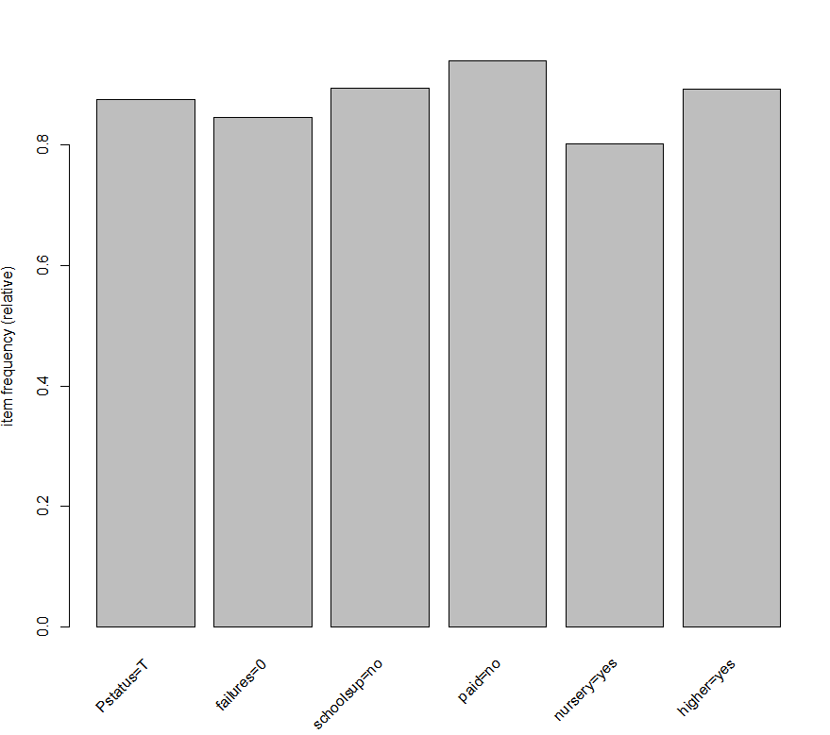

* 1. How did you tune FP Growth?  Why?

By using FP Growth , we are trying to identify the other different attributes to have them better related, and where FP Growth would be considered for smaller Datasets, in fact which would not be helpful most interactive databases.  
  
  
  
  
  
  
Fp growth:

1.

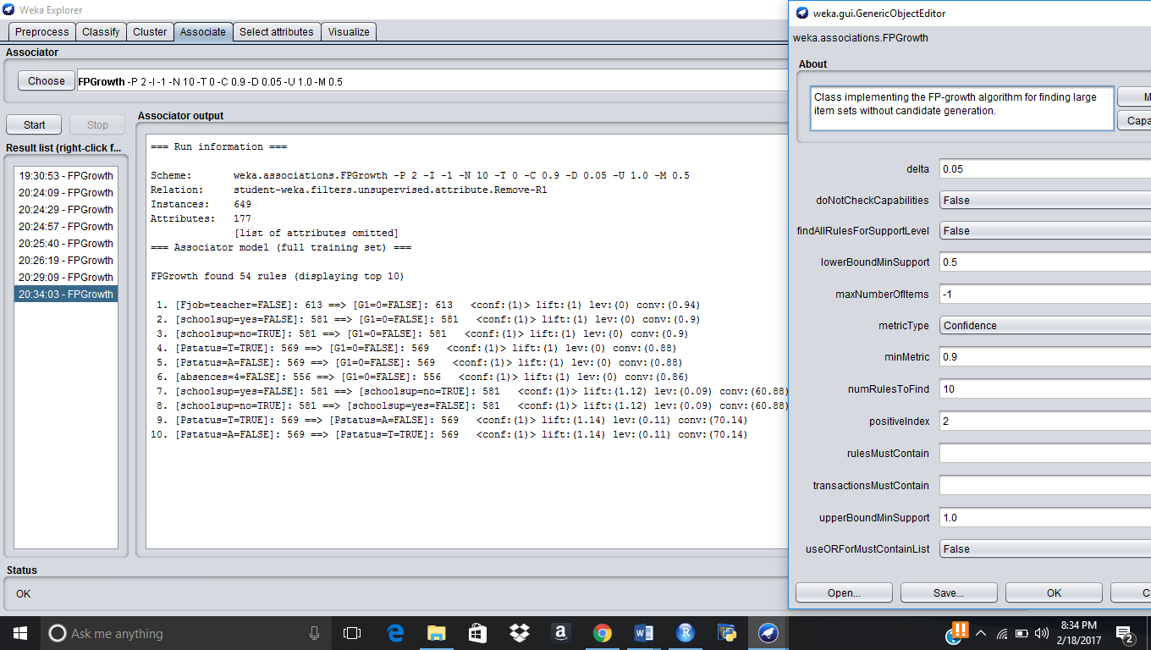

2.

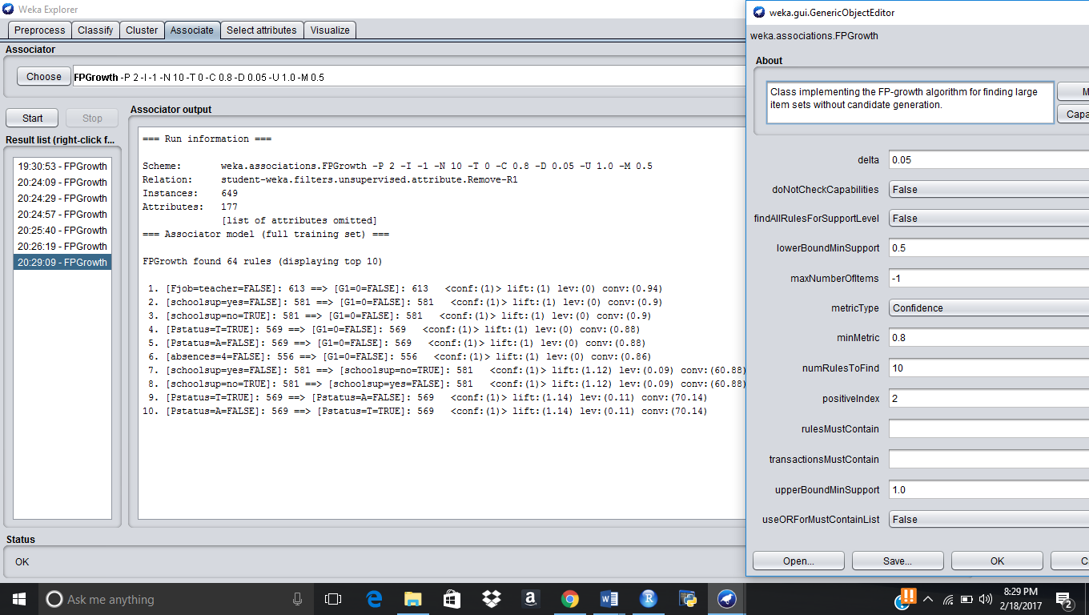

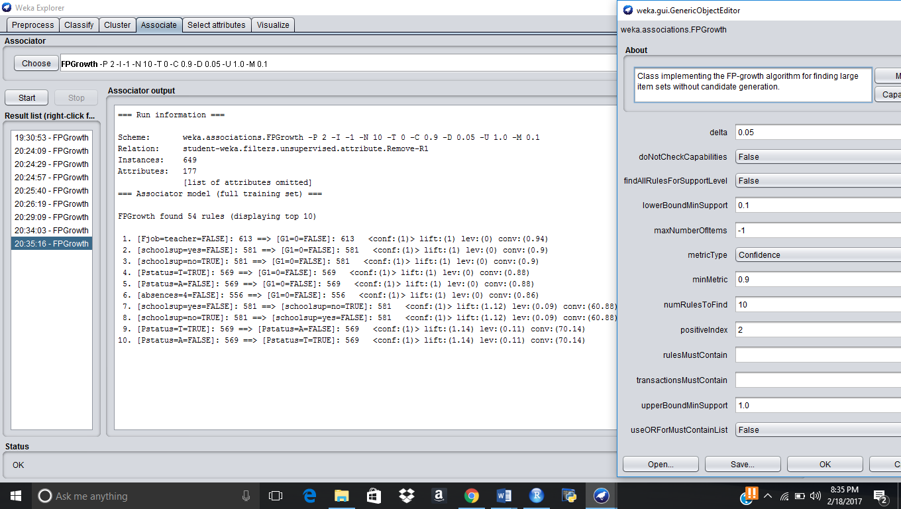3.

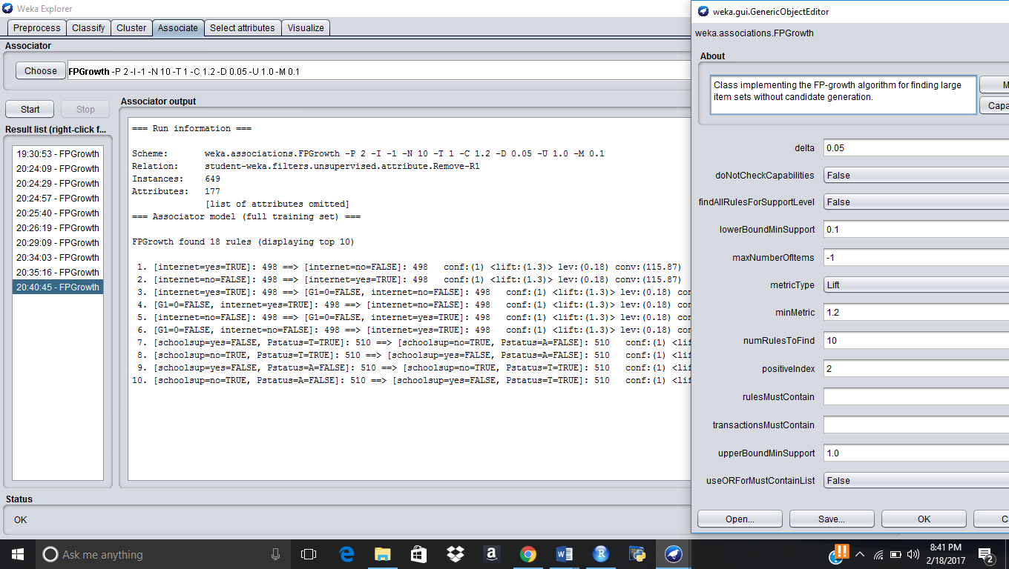4.

* 1. Which algorithm produces better results for your dataset and why?

FPGrowth is what we considered that which it would provide best results for a larger dataset, and where it has identified the and provided logical relation in between the attributes and where it has identified with lift and variation between confidence and support has provided best relation and as by varying the values to infd the best relation between the values.

* 1. What do the results tell you about the data?  What business, political, or medical decisions could management make as a result of your analysis?  Why or why not?

Our dataset has settled with various outcomes, and by making change with various certainty, support, and it has determined with various yield. Keeping the understudy review in imperative, we recognized couple of Instances were a review get affected. By utilizing our dataset , here are the a portion of the business choices which can be thought to be taken if conceivable.

1. If the father occupation is an instructor, and after that it would affect understudy review, and make a higher estimation of certainty, which is giving 95% of exact information.

2. If the Pstatus is valid, then it would affect understudy review decidedly for more prominent outcomes as the certainty gave by the outcomes is the second most noteworthy which affect the understudy review.

3. If the Student nonattendance to class , then it would affect understudy review adversely.

4. Famrel is one vital, where if the parent are connected, then it would make best grade for the understudy, and according to judgment skills it would consider to result to genuine.

5. If a man is savoring more weekdays, then he is considered to savor more ends of the week too, thus which deciphers that even these focuses would likewise identified with understudy review, yet how steadily keeping age as component, we can diminish the drinking of understudy who are beneath or under age.

6. If we can have famrel to be existed, when in doubt it helps in recognizing the best understudy review and aides in making a compelling cor between the properties and relationship of the traits distinguished.

So from our dataset, these are a portion of the business choices which can considered which can be taken by authorities for further handling and choices.